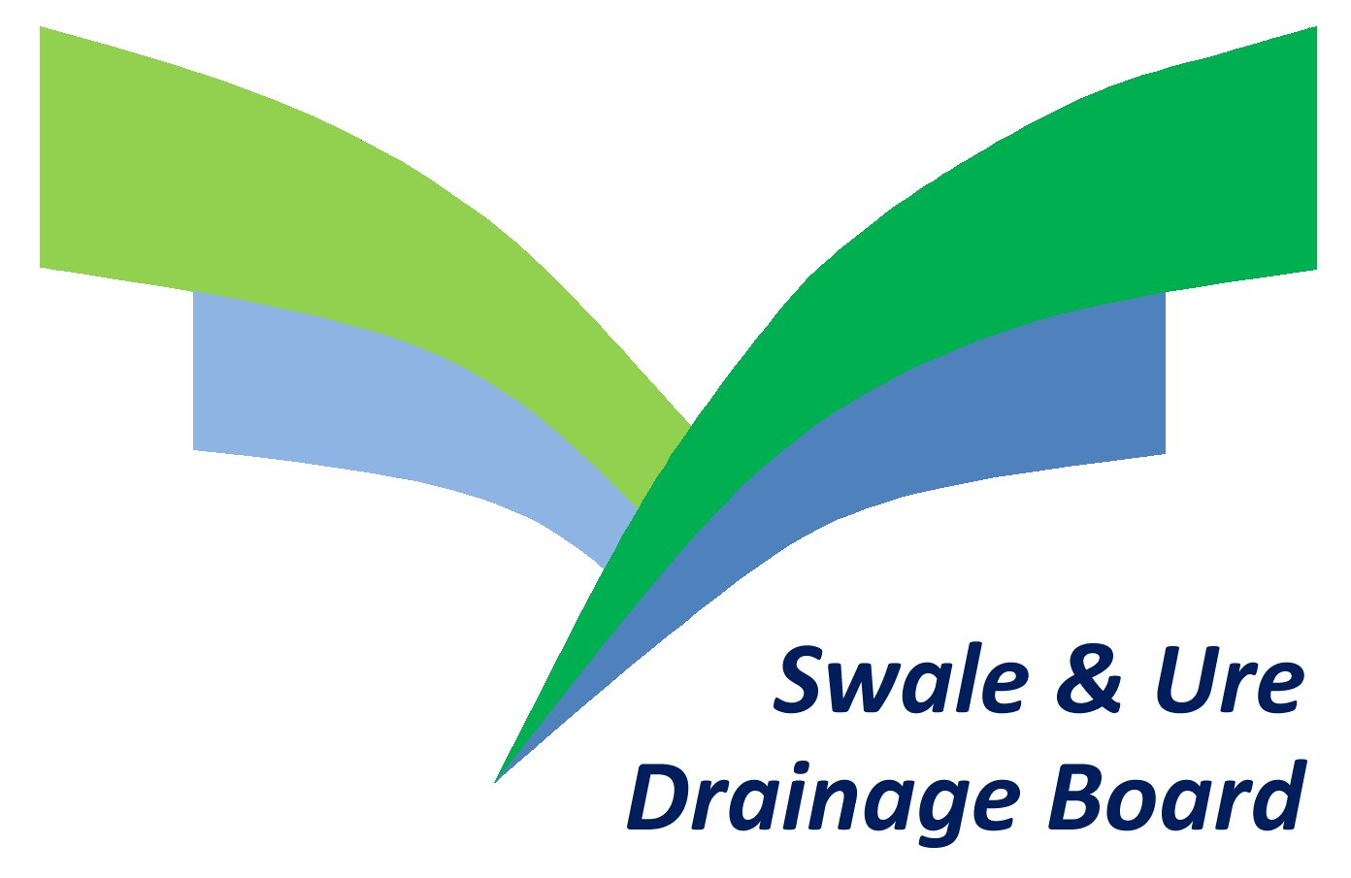

Publication Scheme for The Swale & Ure Drainage Board

What is and why does the Swale & Ure Drainage Board use a Publication Scheme?

The Freedom of Information 2000 (“the Act”) gives a general right of access to recorded information held by public authorities and sets out exemptions from that right and places a number of obligations on public authorities. Further information about the Act can be obtained from The Information Commissioner (http://www.ico.gov.uk)

The Board is required to adopt and maintain a publication scheme setting out the classes of information it holds, the manner in which it intends to publish information, and whether a charge will be made for the information. The purpose of a scheme is to ensure a significant amount of information is available, without the need for a specific request. Schemes are intended to encourage organisations to publish more information proactively and to develop a greater culture of openness.

What information is routinely available?

The Drainage Board information is grouped into seven classes:

1. Who we are and what we do
Organisational information, structures, locations and contacts.

2. What we spend and how we spend it
Financial information relating to projected and actual income and expenditure,
procurement, contracts and audited accounts.

3. What our priorities are and how we are doing
Strategies and plans, value for money indicators, audits, inspections and reviews.

4. How we make decisions
Decision making processes and records of decisions.

5. Our policies and procedures
Current written protocols, policies and procedures for delivering our services and
responsibilities.

6. List and registers
All statutory and non-statutory registers.

7. The services we offer
Information about the services we currently provide including leaflets, guidance and
newsletters produced

How to access the information?

The information contained in each class may be accessed through a variety of means and in a number of formats where available. All information is available for inspection on request and by
prior appointment, where appropriate copies can be made available. A Charge may be applied to the information supplied; each case is considered individually. Information will be provided within
28 days, if the request is reasonable.

- On the Swale & Ure website
Some information will be available on the website. This information is non-chargeable.

- By e-mail
E-mail info@sandudb.gov.uk with ‘Freedom of Information Request’ in the subject line.

- By post
To obtain paper copies of the information please contact:
Ian A Thornton, Chief Executive and Clerk of the Board
Swale & Ure Drainage Board
2-4 Jockey Lane, Knaresborough
North Yorkshire HG5 0HG
Tel: 01423 862271

Please note that where hard copies of information will normally be supplied upon request, multiple copies cannot normally be provided.

- In Person
Please contact the office to arrange an appointment.

Charges and Exempt Information

Charges may be imposed for the provision of some of the information within this publication scheme. Where a class contains information which may levy a charge this is made clear with a £ symbol shown below. In adopting this scheme there has been an effort to be as open as possible but there are instances where, for legitimate reasons, certain information is not available. Where this is the case the reasons behind the decision to exclude certain information is clearly stated.
Justification for excluding information is made in consideration of the general exemptions contained in the Act, the Environmental Information Regulations, the Data Protection Act or where it may be of a confidential or commercially sensitive nature.

All copyright is reserved by the Board.

The Information Available:

- Who we are and what we do
Constitution of the Board, including their structure & membership
Geographical area covered
Outline of responsibilities
Location of offices and contact details

- What we spend and how we spend it (£)
Annual accounts
Audit of accounts
Revenue and capital spending plans
Procurement Regulations
Funding: details of drainage rates, special levies, grants and other financial contributions
Board Members and Officers allowances and expenses
Contracts awarded and their value

- What our priorities are and how we are doing (£)
Aims, objectives and plans
Performance against aims and plans
Programme of works

- How we make decisions
Board meeting and sub-committee minutes
Public consultations
Reports of advisory groups
Environmental Impact Assessments
Assessment of flooding risks
Other publicly available reports

- Our Policies and Procedures
Policies and procedures for the conduct of the Board’s business
Policies and procedures about the provision of services
Policies and procedures about employment matters
Whistle blowing policy
Anti-fraud & corruption policy
Data protection policy
Freedom of Information Publication Scheme
Customer complaints procedure
Charging regimes and policies

- List and registers (£)
Register of Assets
Rate Book
Electoral Register (for the purposes of an Election of IDB Members~)
Register of Members’ Interests
Members Attendance Register

- The services we offer (£)
Regulatory role
Byelaws
Information for landowners, developments and operations
Notices, leaflets and guidance
Media releases
Details of the services for which the Board is entitled to recover a fee together with those fees.

Feedback

Feedback, comments or complaints about this publication scheme should be directed to the Clerk or
The Chairman of the Board, forwarded to the address stated in Section 3 above; “How to Access Information 3. By Post”. If you are not satisfied that information is being published in accordance
With this scheme you can refer your complaint to the Information Commissioner:

The Case Reception Unit
Customer Services Team
Information Commissioners Office
Wycliffe House
Water Lane
Wilmslow
Cheshire
SK9 5AF

www.ico.gov.uk/complaints/freedom_of_information.aspx

