This Environmental Policy has been produced by the Swale & Ure Drainage Board (the Board) to explain how the Board’s activities, associated with water level management, comply with its legislative duties of environmental protection.
The Board recognises the need to positively demonstrate that its watercourse maintenance and capital operations are undertaken in a way that manages water levels to deliver land drainage and flood risk management whilst conserving and enhancing biodiversity thus making a positive contribution to the environment.

Background
The Board is the relevant authority charged with the provision of sustainable water level management across its District. The District covers 20,507 ha of low-lying land dispersed in slivers across the Vales of York and Mowbray between (North-South) Appleton Wiske and Wetherby and (East-West) Brompton-on-Swale and Husthwaite as shown on the adjacent plan. The full extent of the District can be viewed in greater detail on the Board’s website at www. http://sandudb.gov.uk/. The slivers of land forming the District are areas which drain into the Rivers Ure, Wiske, Swale, Nidd and Cod Beck.
Land within the District has a lower level of flood risk than would exist without the protection offered by a network of watercourses, drains and connecting ditches maintained by the Board. These man-made, or heavily modified natural features, demonstrate the effect that water level management has had in creating the present landscape from a previously marshy floodplain.
Across its District, the Board has a supervisory role in respect of all matters relating to the drainage of land, set out in the Land Drainage Act 1991 (as amended).
The Board operates under permissive powers when undertaking works and watercourse maintenance within its District. Direct maintenance is limited to those watercourses the Board considers strategic to the drainage of the District. These watercourses extend to 548 km in length.
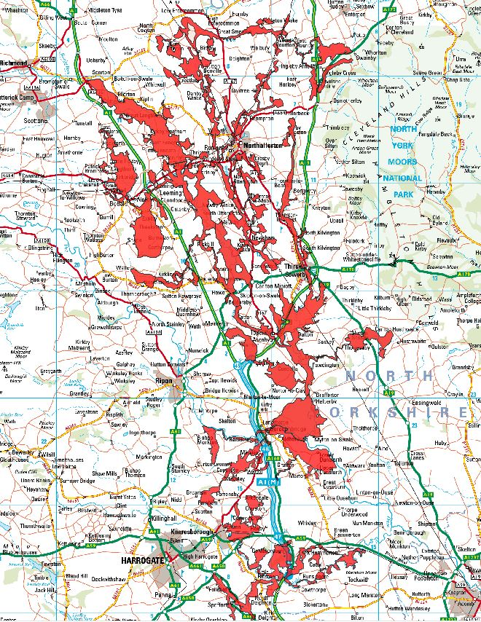
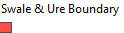

Statutory function
Internal Drainage Boards are subject to legislative general environmental duties, requiring them to exercise their function in such a way that conserves and enhance biodiversity and minimises harm to interests of recognised importance.
The function of the Board is provided for in the Land Drainage Act 1991 (as amended). The Act provides for general drainage of an IDB District and Flood Risk Management Works within that District.
General Drainage of the District includes the power to:
- maintain existing works
- improve existing works
- construct new works
Flood Risk Management Works within the District include activities such as:
- maintenance of existing works
- operation of existing works
- improvement or repair of existing works
- construction of new works
- maintaining or restoring natural processes
- monitoring, investigating or surveying a location or a natural process;
- reducing or increasing the level of water in a place
- altering or removing works.

Beneficiaries of water level management
Management of water levels is beneficial to multiple stakeholders of the District:
- Network Rail for the East Coast Main Line,
- Highways England for the A1(M),
- Local Authorities with responsibility for smaller roads
- Businesses and residents within the area.
There can be a fine balance between several, and sometimes conflicting interests. Current practices have evolved through close co-operation between the Board and its stakeholders over many years.

Maintenance
To manage water levels, the Swale & Ure Drainage Board undertakes routine maintenance operations on strategic watercourses. The Board considers the impact of maintenance work on the conservation interest of the riparian and aquatic environment.
Maintenance can include:
- the control of bank-side vegetation
- control of aquatic vegetation in the channel
- tree works where appropriate to facilitate access to the watercourse
- de-silting when necessary
Bank side maintenance is undertaken for the following primary reasons:
- Health and Safety criteria associated with de-weeding or de-silting operations permitting clear sight of the watercourse
- The control of successional scrub.
- Provision of a clear passage for water flow
- Inspection of watercourses and associated structures
- Stimulating the growth of bank side vegetation thereby maximising bank protection from erosion

Aquatic vegetation maintenance is undertaken for the following primary reason:
- To permit the free flow of water through strategic watercourses thus facilitating land drainage
De-silting maintenance is undertaken for the following primary reason:
- To ensure sufficient capacity is retained within the watercourse for storage purposes during inundation events
To deliver a maintenance programme the Board must comply with Environmental Permitting (England and Wales) (Amendment) Regulations 2018 and register its exemptions for the use, treatment and disposal of waste arising from the work.
To deliver any improvement works the Board must comply with the Environmental Impact Assessment (Land Drainage Improvement Works) Regulation 2017.
Management of water levels through pumped activity must achieve station compliance with Eels (England and Wales) Regulations 2010.
Management of the aquatic environment through de-silting processes must not adversely affect protected fish, mollusc or eel species
Where Board activity is considered likely to impact on a Site of Special Scientific Interest (SSSI), the Board must comply with s61(c) Land Drainage Act 1991 (as amended) and consult Natural England before undertaking any operation or activities which appear likely to destroy or damage any flora, fauna or geological or physiographical features by reason of which the land is of special interest. SSSI within the Board’s District are:
- Upper Dunsforth Carrs
- Swale Lakes
- Farnham Mires
- Hay-a-Park
- Aubert Ings
- Bishop Monkton Ings
- Newsome Bridge Quarry

Policy Aim
To manage water levels across the District using techniques which cause minimal environmental damage whilst facilitating
- an adequate water supply for abstraction
- land drainage and flood risk mitigation.
- management of nature conservation interests.

Policy Objectives
To achieve its aims, the Board will:
- deliver its maintenance programme following environmental best practice guidance detailed in the Drainage Channel Biodiversity Manual “Integrating wildlife and flood risk management”.
- undertake de-silting operations in a manner which reduces the risk of negative impact on protected aquatic species through following best practice guidance
- deliver its maintenance programme following its Biosecurity Policy Procedures which seek to reduce the risk of spreading Invasive Non-Native Species
- register its Environmental Permitting Exemptions for the use, treatment and disposal of waste arising from the work.
- seek to control the inappropriate use, alteration and culverting of drains and ditches within the District where this may have a detrimental effect on biodiversity
- seek to reduce its CO₂e emissions wherever possible
- promote the targets of its Biodiversity Action Plan associated with maintenance operations and capital works.
- work with Natural England and others to promote the enhancement and protection of nature conservation interests, in so far as may be consistent with operational functions.
This policy was adopted by the Board on 6th June 2019. Reviewed by Board Officers September 2023, approved by the Board at its meeting 16 November 2023.
This policy will be reviewed following any changes in legislation but in any event every 5 years.
Latest date for review 2028.

