MINUTES OF THE KYLE & UPPER OUSE IDB MEETING
HELD ON MONDAY 1st DECEMBER 2025
AT THE GALTRES CENTRE, EASINGWOLD

1 Present Mr R Shedden (Chair), Mr P Bielby, Mr A Boddy, Mr P Cowton,
Mr I Galtrey, Mr R Pennock, Mr G Robinson, Mr R Spilman,
Mr J P Stirke, Cllr A Hook, Cllr Mrs P Mullen, Mr M Henderson,
Cllr Mr N Knapton, Mr J Corden

In attendance - Mr N Everard (Clerk of the Board)
Mr P Jones (Consulting Engineer)

2 Apologies None

3 Chair/Vice Chair Following the election of the new Board, Mr R Shedden was elected
Chair and Mr A Boddy was elected Vice Chair.

4 Finance Committee The Board appointed the Chair and the Vice Chair.

5 Welcome/Vote of The Chairman welcomed the newly elected and appointed members
Thanks and gave a vote of thanks to retiring members.

6 Declaration of None.
Interest

7 Minutes The Minutes of the meeting held on 23rd June 2025 were approved and
signed and there were no matters arising.

8 Consulting DEFRA Investment Reform
Engineers Report
DEFRA published their new FCERM (Grant in Aid) funding policy in October following public consultation and the new rules are due to be in place from April 2026 which include:
- existing projects and assets - eligible for 100% of costs for refurbishing existing assets.
- new or improved projects and assets - eligible for 100% for the first £3 million, and 90% for costs above £3 million.
Details of any revised prioritising scoring are awaited which will determine whether projects are eligible.
They have also removed the 2012 rule which means that all households built before and after 2012 may be considered as benefits within future projects.

Asset Management System
Consulting Engineers have been investigating the options for the future Asset Management System due to the legacy systems’ data input device no longer being supported by suppliers.
In reviewing options to present they have reviewed, contacted and approached the multiple suppliers with the following identified to consider moving forwards:
- AMX (current supplier for EA and CRT)
- DATB (currently provides AMS for HS2, Thames Water and Welsh Water)
- Mobiess (asset, work order and inspection packages developed for on site)
They have developed a proof in concept with thanks to DATB and have had demonstrations from AMX as well as setting out the Board’s likely requirements from the system and these discussions and research have helped develop the Scope.
They are now preparing an initial cost comparison to present to the Board.
The initial quality comparison can be seen below.

Ordinary Watercourse Maintenance
A pre-start maintenance meeting was held on 7th July 2025 agreeing maintenance works for the 2025/26 maintenance season with the Chairman, Board employees, Asset Manager and Contractor.
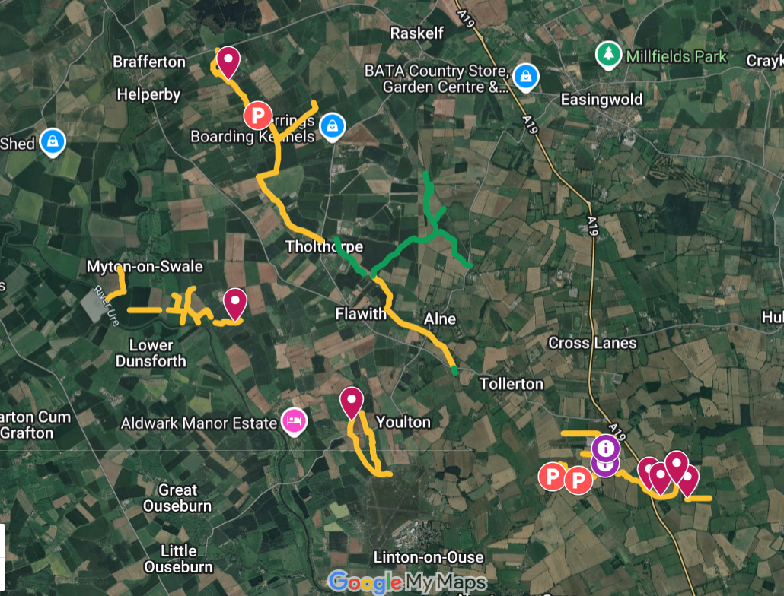
The Contractor has completed 30,566m predominantly flailing including 4,842m desilting outlined on the map overleaf.
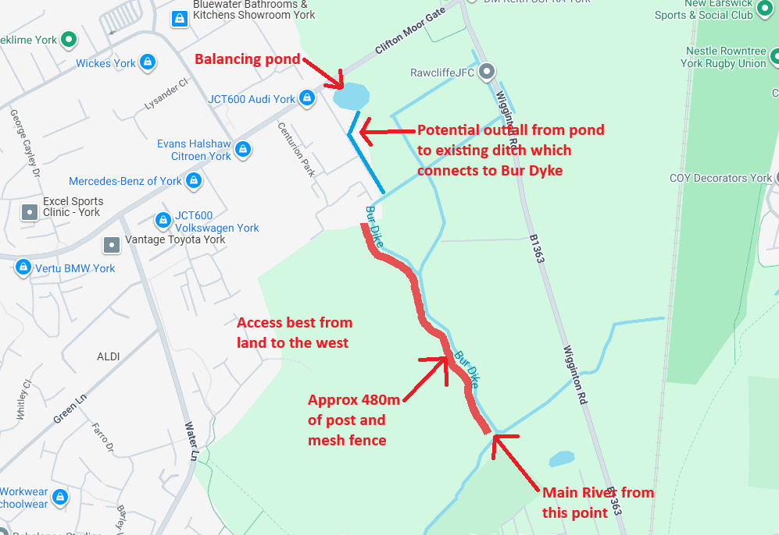
Employees including the new flail mower / tractor operator has been focused on piling works, watercourse maintenance, improving access to maintain watercourses (Easingwold allotments), and investigation access to maintain Bur Dike (under review) upstream of Main River.

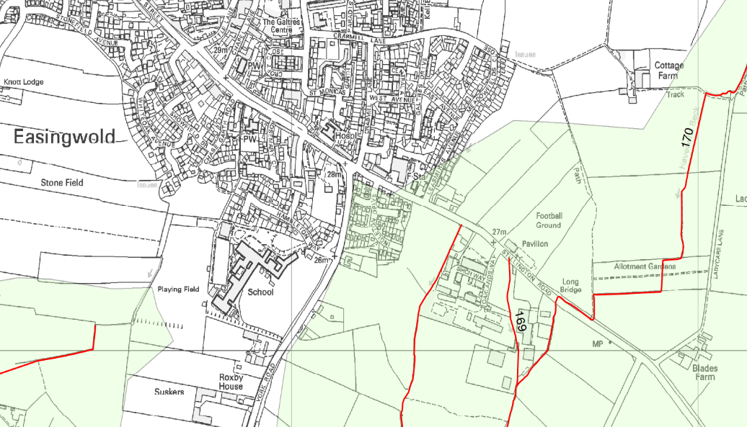
The Asset Manager has worked with Employees and the allotment managers to successfully maintain the ordinary watercourse ‘Haverwits Beck’ (Breadlands Allotments, Ladycarr Lane, Easingwold) which employees repaired bank slumping including piling. Access has previously been difficult due to the allotment plot boundary fences being at bank top. Agreement has been made to provide permanent maintenance access on one side of the beck, with this now in place on the east bank to the north of the access track and further access to be provided on the west bank, south of the access track when the plot resident vacates the plot in the next 2-3 years. This will ensure that future maintenance is possible through this section.

Planning Applications

Planning applications have been reviewed on a weekly basis and 14 have received comment between17th June and 28th November 2025 on behalf of the Board.
Applications may not result in a need for consent, but should an applicant wish to discharge to a watercourse or work within 7 metres of a watercourse they are informed of the Boards consent requirements.

Land Drainage Act 1991 Section 23 and 66 Consents

3 no. consents have been provided on behalf of the Board between 17th June and 28th November 2025.
The Asset Manager has been in discussions with the Developers off Leasmires regarding the existing 900mm diameter culvert downstream of the development. The developers have in principle agreed to CCTV the pipeline subject to local access agreement with the landowner.

9 Risk Management/ The Clerk reported that he had met with the new insurance broker and
Strategy & Policy would ensure that cover was in place. The Health & Safety inspection is to be scheduled.

10 Audit The Clerk reported on the Audit Report from the external auditors
with reference to publication of minutes on the Board’s website and rate arrears. The Clerk was authorised to publish signed minutes and not draft minutes on the website on the basis that this was a recommendation and not a legal requirement.

The Clerk will prepare a schedule of rate arrears which have been delayed due to the installation of the new DRS365 system.

11 Appointed Members Mr M Henderson agreed to raise the point about vacancies of City of
York Council appointed members.

12 Direct Labour The Foreman and the Machine Operator are working to capacity and
that maintenance was progressing well. The Clerk was authorised to obtain updated mobile phones for the employees.

13 Consulting The Board approved the Finance Committee’s recommendation for an
Engineers Contract increase of % with effect from 1st April 2025.

14 Clerks The Clerk had advised that the Clerkship service provided by Hunter Remuneration Gee Holroyd was no longer economic and that under the existing
Agreement one year’s notice was provided to cease the service. The Clerk will ensure smooth transition to a new provider and will report to the Finance Committee on alternatives.

15 Accounts Accounts for Payment Schedule numbers 31, 32, 33, 34, 35 and 36 were
For Payment approved in the sums of £82,699.63, £49,563.36, £30,900.17, £108,108.61, £34,641.74 and £24,252.32 respectively.

16 Next Meeting The Clerk reported that the next meeting was scheduled for Monday
22nd June at 2.00pm at the Galtres Centre, Easingwold.

Mr R C Shedden…. Chairman

2nd February 2026…...Date

